Friday
- Roles
- Photon
- Plan the concrete development plan for each role by yourself??

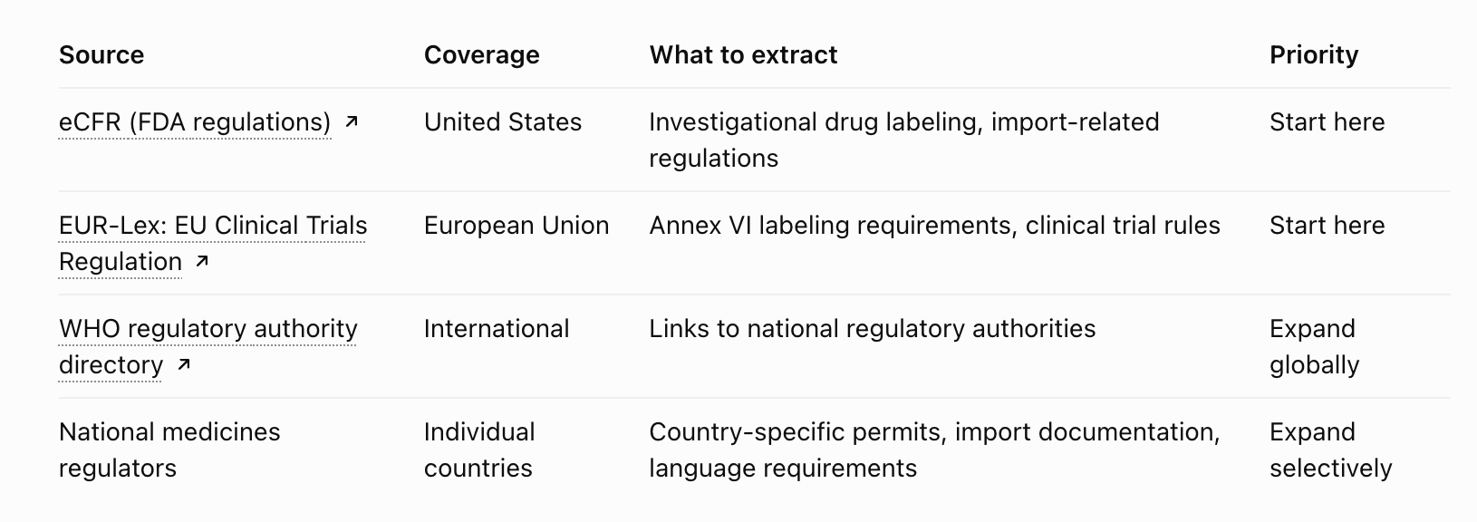

- Extract law data
- United states
  - https://www.ecfr.gov/current/title-21/chapter-I/subchapter-D/part-312/subpart-A/section-312.6
- EU
  - https://eur-lex.europa.eu/eli/reg/2014/536/2022-01-31/eng?utm_source=chatgpt.com
- Canada
  - https://www.who.int/teams/regulation-prequalification/regulation-and-safety/regulatory-convergence-networks/certification-scheme/contacts?utm_source=chatgpt.com
- Japan
  - https://www.who.int/teams/regulation-prequalification/regulation-and-safety/regulatory-convergence-networks/certification-scheme/contacts?utm_source=chatgpt.com
- Nepal
  - https://www.who.int/teams/regulation-prequalification/regulation-and-safety/regulatory-convergence-networks/certification-scheme/contacts?utm_source=chatgpt.com

- Specific drug (metformin?)

Steps
- Gather label data/laws (maybe two people)
- Photon (one person)
- Plan a general interface with the features

